We recommend at least 15m of coax, and no counterpoise. Put a common mode choke, also available from us, at the transmitter side of your coax. The antenna uses the shield of the coax as its counterpoise.

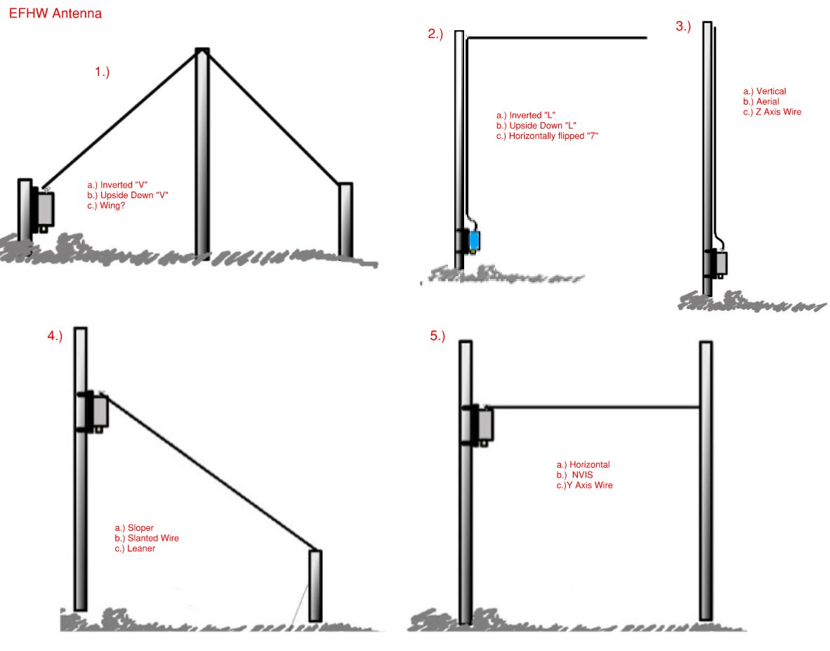

**User manual:**

**Bombastik 300W EFHW 10-80 antenna**

**Bombastik 1000W EFHW 10-80 antenna.**

You have made an important decision to buy a quality hand-crafted antenna from Bombastik, and we wish you many happy days with your amateur radio pursuits.

Setting up an EFHW (End-Fed Half-Wave) antenna can be a rewarding project. We've had the pleasure of using our own transformer and antenna kits and the performance can be impressive with the right setup. Let's walk through the steps and give some tips to optimize your antenna setup.

Before we start, please note:

**Our 300W EFHW Bombastik antenna** is capable of handling 300W voice SSB and CW and 70 - 100W digital modes, but we suggest using less than 100W as running your radio at full power and high duty cycles is not good for your radio.

**Our 1000W EFHW Bombastik antenna** is capable of handling 1000W voice on SSB and CW and a recommended maximum of 300W on digital modes.

*****

**Step 1: Understanding the EFHW Antenna** - An EFHW antenna is essentially a half-wavelength of wire that's fed at one end. The beauty of this design is that it doesn't necessarily require a tuner and can be mounted in various configurations to suit your location.

**Step 2: Selecting the Location** - Your operating frequency and available space will determine the length of your antenna. You'll want a clear area, free from obstructions, and as high as possible to ensure a good radiation pattern. Common configurations include straight horizontal, sloper, inverted-V, and vertical.

**Step 3: Measuring and Cutting the Wire** - For a half-wave antenna, the formula is:

468 / frequency (in MHz) = length (in feet). Convert this to meters by multiplying by 0.3048.

To determine the length of an EFHW (End-Fed Half-Wave) antenna wire directly in metric terms, you will need to know the frequency in megahertz (MHz) that you plan to operate on. The formula is:

Length in meters = 1535.43 divided by Frequency in MHz (for example 1535.43 / 7100Mhz = 21,6m)

​Precision is key, so measure carefully. Before cutting the final length, make the wire slightly longer and fold over the end until your SWR is to your satisfaction. Also note that the SWR can change somewhat when using different setup configurations.

**Step 4: Choosing the Matching Transformer,** A 49:1 unun is typically used to match the high impedance of the end-fed wire to the 50-ohm coax feedline. This transformer is critical for a well-functioning EFHW antenna.

**Our 300W** **EFHW Bombastik antenna** is capable of handling 300W voice SSB and 100W digital and CW modes, but we suggest using less than 100W as running your radio at full power and high duty cycles is not good for your radio.

**Our 1KW EFHW Bombastik antenna** is capable of handling 1000W voice on SSB and a recommended maximum of 300W digital or CW.

**Step 5: Coax Length** - Ideal coax lengths are subject to debate, but as a rule of thumb, try to avoid multiples of a half-wavelength at your operating frequency to prevent feedline resonance. Use a quality 50-ohm coax cable like RG-8 or RG-213 for lower loss, especially for longer runs. For a short run of between 10 and 15m you can even use RG58. On the 1KW version only use RG213 or LMR400.

**Step 6: Installing a Choke,** A choke near the transmitter or at the feed point of the antenna is essential to prevent common mode currents. You can use a commercially made choke or create one using several turns of your coax in a coil, secured by electrical tape or cable ties.

**Step 7: Mounting and Safety** Ensure your antenna is securely mounted and out of reach to avoid any accidents. Safety first – avoid power lines and ensure proper grounding.

**Step 8: Testing and Tuning** Once everything are connected, test your antenna with an SWR meter to ensure it's resonant at your desired frequencies. Adjustments may be needed by trimming the wire or adjusting the position.

**Step 9: Enjoy the Airwaves** With everything set up, it's time to power up your transceiver and start making contacts. Enjoy the ease of use and reach that your new EFHW antenna affords.

For a more immersive tutorial, we recommend reaching out to local ham radio clubs or experienced operators who can provide hands-on advice and perhaps even assist with your first setup. Each installation is unique, and there’s nothing like practical experience to understand the nuances involved.